**PRACTICE 1**

**MARK 8**

Looking at this photo, I can see that this is a very popular tourist destination. The scenery here is very beautiful and there are a lot of people visiting. I think they are tourists and they are taking photos. I think it is a sunny day because there are a lot of people with umbrellas and hats. In the photo there is a very clear blue lake and there is a lion made of stone spouting water into the lake which looks very beautiful. In the distance, there are beautiful high-rise buildings. When I look at this photo, I really want to come there and try it once. I hope to visit this place in the future. Finally, I want to say that this is a very beautiful photo. I like it very much.

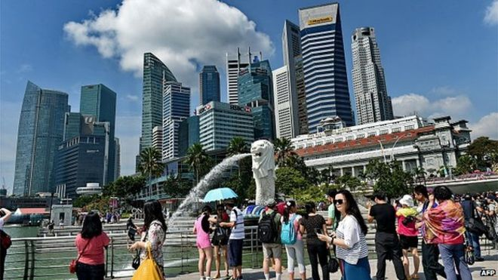

**MARK 8.5**

I will give some information about this photo. Looking at the photo I can see this is a high end resort because there is a very beautiful swimming pool, the buildings are very big and luxurious. In the photo there are some people swimming in the pool and some others sitting on the chairs arranged around the pool. They are all wearing very nice swimsuits. there appears to be a young lady. She is wearing a blue T-shirt and a white skirt. She has long black hair. I think it is a very beautiful day because the sky is blue and there is light sunshine. In the photo there are also very beautiful trees, especially the 2 trees in the middle of the photo. This photo makes me want to come there immediately. Finally, I want to say that this is a very beautiful photo. I like it very much.



**PRACTICE 2**

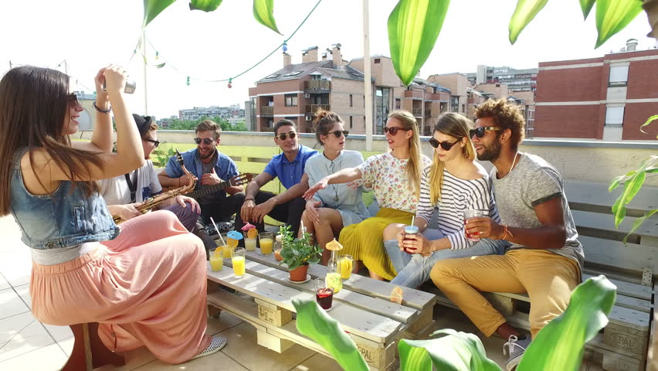

In this photo, I can see 8 young people. They are the same age, I think they are 22 years old. They all wear sunglasses. On the left of picture, there is a girl wearing a short-sleeved denim shirt and a long pink skirt. She is taking photos. Next to her are two man, one is holding a trumpet, he wears a white T-shirt, grey pants and black hat. The other is holding a guitar, he wears a blue shirt and black pants. On the right of the picture, there are 5 young people sitting and talking with each other. Have a black man, he’s wearing a grey T-shirt and yellow pants. Next to him is a girl, she wears black and white shirt and jeans. Next to her is a other girl, she wears flower shirt and yellow dress, she’s talkig to a girl in a light blue jumpsuit. Next to her is a man, he is wearing a blue shirt and black pants. Looks like they’re having a little party. On the table there are cups of juice and a smwll potted plant. Near them there are trees and string lights. In the distance are tall buildings. In my opion, it’s beautiful photo.

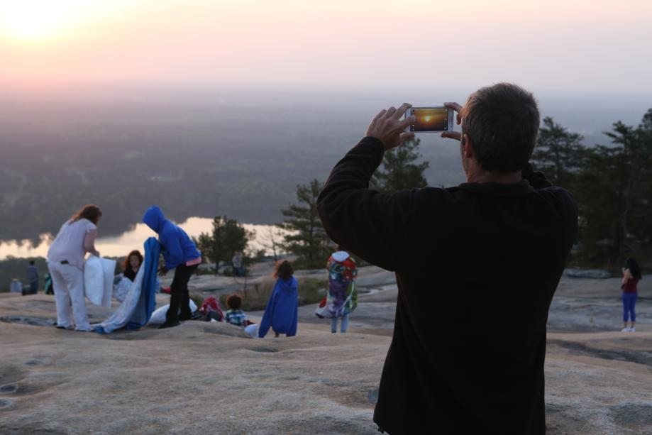

As you can see, there are a lot of people in the picture. there are adults and children. I think they are a family and they are having a picnic by the riverside. the sky is getting dark. On the right side of the photo, there are a lot of trees, I think they are pines. The man is taking pictures of the sunset, the two women are getting ready for a picnic and the kids are watching the sunset. There were a lot of people around, maybe they were also having a picnic. I think this is their weekend break after a week of hard work.

**PRACTICE 3**

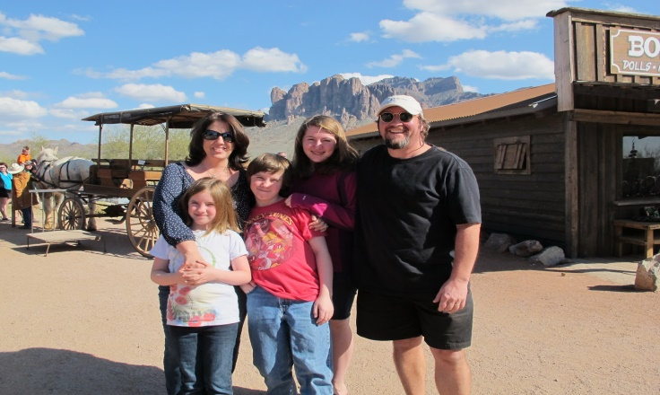

In this photo I can see a family on a farm. I guess they are going sightseeing it could be somewhere in africa because I see behind them a large chariot. This family has 5 people: parents,2 daughters and son. The man is wearing black sunglasses and wear a black suit. The woman is wearing gray long sleved and black glasses. The babies are about 7 to 10 years old. Behind everyone, I see a carriage and in the distance a mountain range. I dont's know what time it is but I think it may be 5pm in the summer. Everyone in this family is very happy. I can see the sunlight shinning and the coulds in the sky. I want to say this picture is very beatiful. I like it very much.

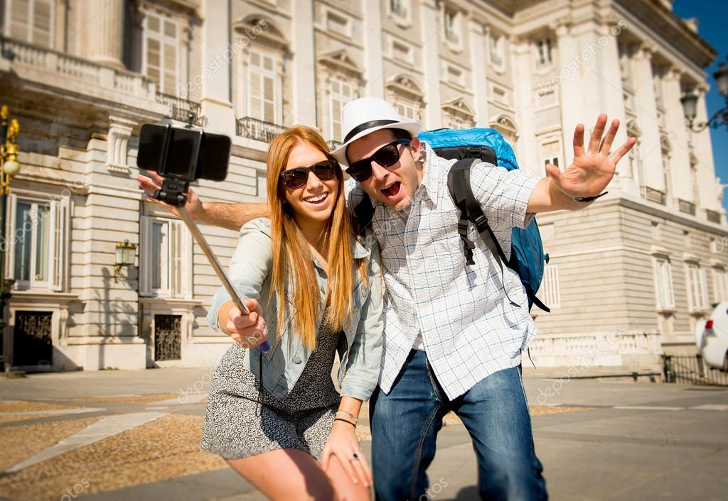

In the Picture i can see couple visiting a town it could be somewhere in europe . Looking at the background of the photo we can see buidings side by side , it can be a famous place . There are 2 people ,the man on the left he is wearing sunglasses and a hat , white T- shirt and jeans . The girl on the right is holding the camera . They are taking picture here to save the memories together . The girl looks very attractive with short skirt and a jacket . The weather is very nice . I like this piture because it is interesting

**PRACTICE 4**



Look at the photo, we can see a mother and two children, a daughter and a son. They are choosing items at the fruit counter at a super martket. Looking at the background of the photo, we can see huge shelves of fruit around them. Mom is picking delicious fruits to put on the scale. The son is holding a small piece of paper, possibly reading the fruit to buy, so that the mother can choose faster. The son is wearing a black long-sleeve t-shirt. This is the scene that often see in the supermarket in the city. I dont know what time it is, but i think it’s 5 pm. Everyone usually go to supermarket to buy ingredient for evening. In my opinion, it’s beautiful picture.



In the picture I can see a woman and a man shopping together at a clothing store. They are probably husband and wife. Looking at the husband on the left of the picture, I think he's about 30. He looks very handsome, wearing a blue blazer and a pair of white casual pants. As for the wife, about 28, she has shoulder-length auburn hair. She is wearing an orange t-shirt. I'm not sure but I think they're choosing a dress for the wife. The husband is watching his wife choose clothes, while the wife is holding a light pink

**PRACTICE 5**



In this photo, I can see people enjoying their day. And I’m sure they are camping. The weather looks so sunny and it’s good for camping. I can see 3 women and 2 men. They are singing with each other and enjoying themselves. They are in their twenties. They are sitting on the ground. 2 men wearing sunglasses. The man on the right is playing guitar. The woman in middle got straight, blonde hair, and the other 2 got straight, black hair. They seem to have a good time. In my opinion, this is a happy picture.



In the picture, I can see them working in groups. There are 4 people: 2 boyfriends and 2 girlfriends. I think they are colleagues. They are exchanging jobs. they are about twenty years old. They are in a room. They are sitting next to a round wooden table. On the table, there is a computer and many papers. The man is pointing at the computer. Two women are talking to each other. One of the two men is wearing a hat and glasses. A woman with short curly hair and a woman with long hair. Maybe this group work session is very effective. In my opinion, this is a interseting picture.

**PRACTICE 6**

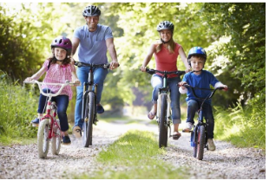

In the photo, I can see a family of 4 including parents and two children, one boy and one girl. Dad is about 37 years old, wearing jeans and a blue t-shirt. Mom is about 35 years old wearing jeans and an orange t-shirt. Two childen about 7 years old. They ride bicycles together. Each person has a bicycle and they have helmets. This family is very cheerful and happy. Around them were a lot of grass, flowers and trees. The weather is hot and sunny. I don’t know what time is it but I think it could be in the morning. This is a beautiful full-color photo.

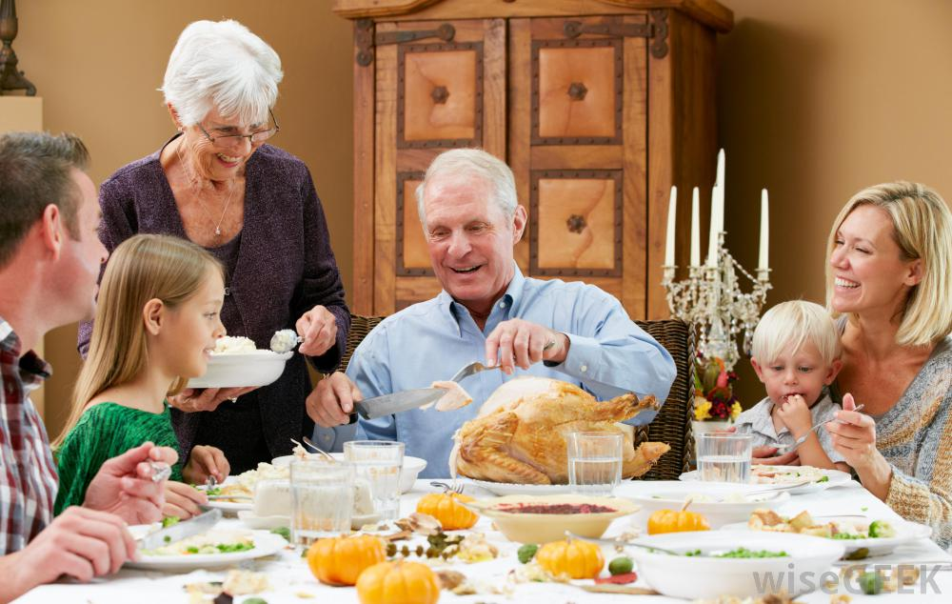

In this photo, I can see extended family Europe. It’s special thing, because almost family is nuclear family in Europe.

The family have 6 members. The oldest member is grand parents. They have white hair and wrinkles in their face. The grandpa is wearing a long-tees blue shirt. He is cutting the Turkey. I guess the family have a meal for the Thankgiving day. The grandma is wearing purple denim coat. She is holding a spoon in the left hand and a sauce bowl in the right hand. She is dividing a sauce for her husband, son, daughter in law, grand daughter and grand son. They are smilling. I think they have some funny story. They look so happy.

The cupbroad and the wall behind grandpa have brown color. This color mix with linentablecloth’s color. I think it’s make the picture harmony.

I think the photo is varity color, sound, laugh and happy. This is a quality photo

**PRACTICE 7**



In this photo, I can see six people in the hospital. There are patient, family’s patient, doctor, nurse. In the middle of picture I can see grandfather. He is about 70 years old. He has got white hair. He is wearing a T-shirt. Opposite him, there is his granddaughter. She is about 10 years old. She has got long hair. She is wearing a sweatshirt. Next to her, there are her parent, they seem happy. On the left of the picture, there are 2 people. They are wearing blouse and reading a document. In my opinion, this is a beautiful picture



In this picture, I can see there are some doctor and nurse because they are wearing hospital uniforms. They are in the hospital. On the left of the picture, I can see a woman. She is about 50 years old. She is wearing glasses. She is short yellow hair. She is shaking hands with a woman next to her. Behind her, there are 3 men. The first man is wearing a blouse and others are wearing suits. On the right of the picture, there are some nurse. They are standing in a line. They are smiling. Finally, I want to say that this picture is very beautiful. I like it so much.

**PRACTICE 8**

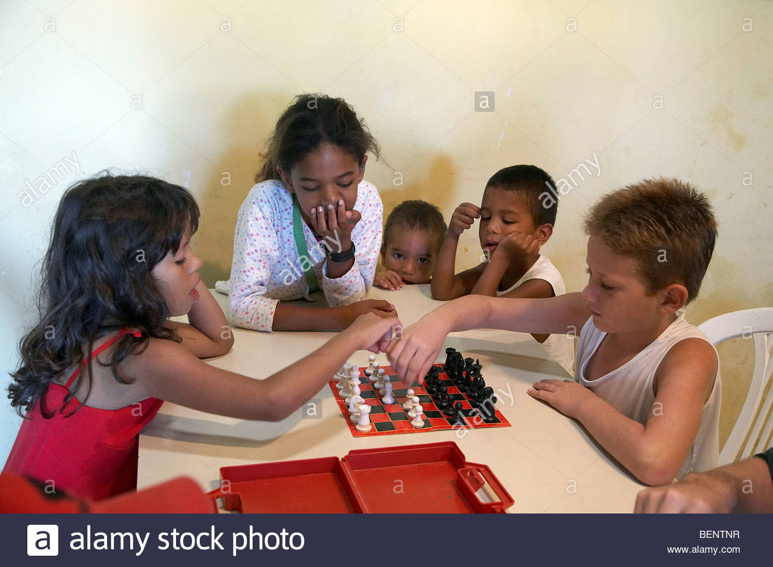

In this photo , I can see 5 people.They are playing chess.I guess they are Africans.In the right of the picture,this is a boy.He is about twelve. He is wearing tank top.He is smart.On the left, we can see a young girl, she is same age as the boy.She is wearing a dress.She is concentrated.Between them, we can see a girl.I think she is elder than the boy.She is wearing a polka-dooted, long-sleeved T-Shirt.She is attentive.Next to her,we can see two children.I guess they are siblings. It is an interesting photo,if you like indoor games.

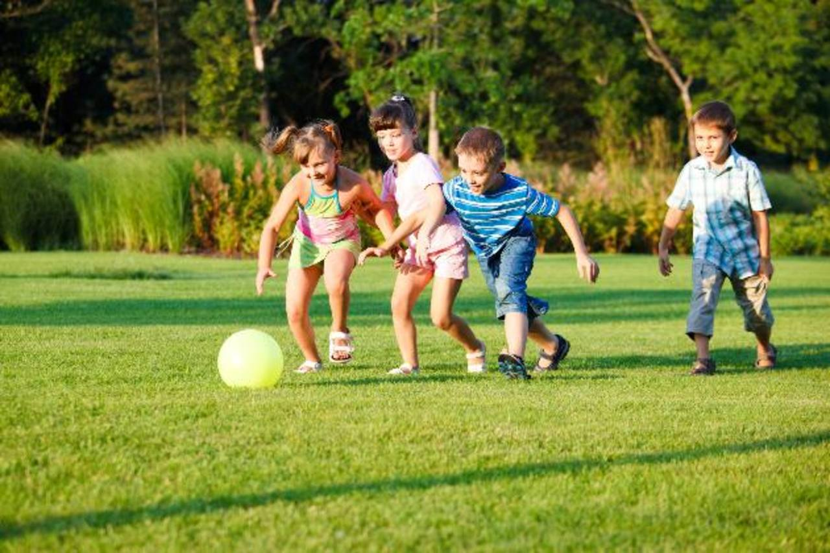

In this photo , we can see four children.I think they in USA.They are playing football.I guess they play soccer in the garden.There are three people challengeing the ball.They are fun.I like the boy next to them.He is looking at the camera.He is wearing shorts and a striped shirt. He is cute. They play football very skillful. Children are playing on the grass field.Behind them,there are some trees.It is an interesting photo, if you like football.

**PRACTICE 9**

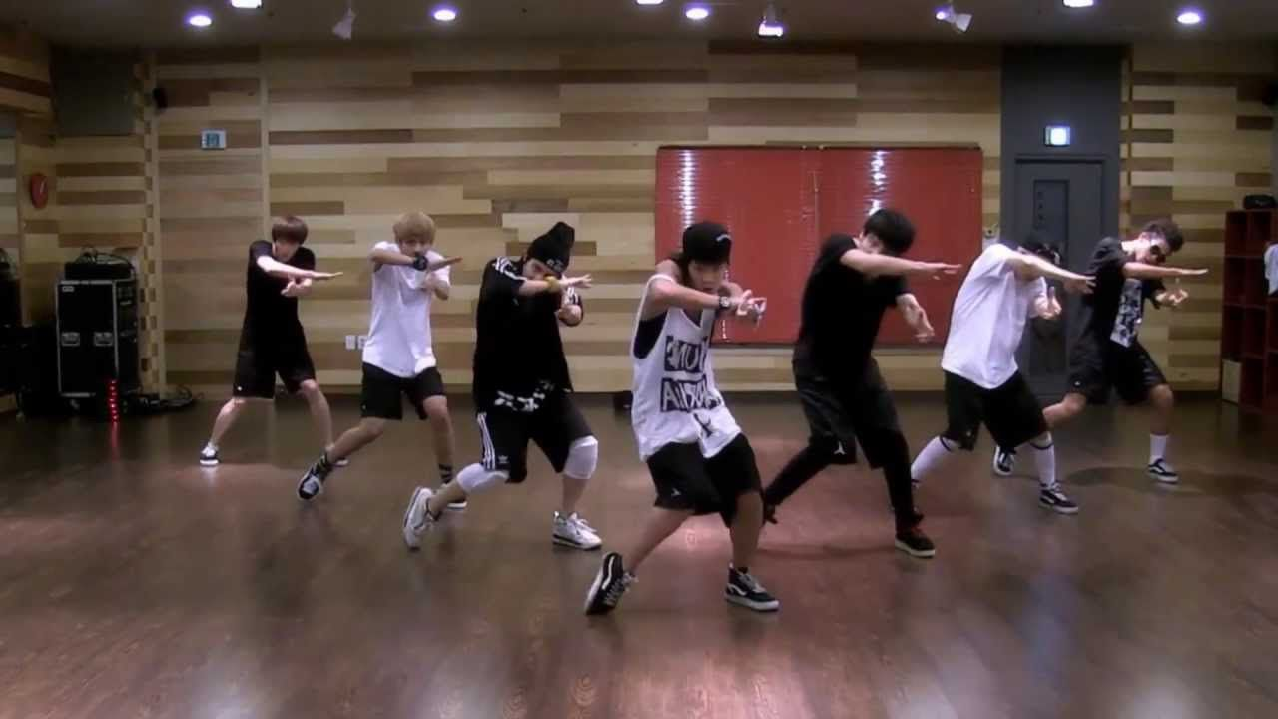

In this photo I can see a dance team is training. In the middle of photo we can see a man who is wearing a white tank top, shorts and a hat. He has got fair skin. His fashion looks quite stylish. This team is training so hard and their movements are so skillful and flexible. I guess they practice to prepare for music festival. The space here is very large and the light is good. I think it’s the perfect place to practice. In my opinion it is an interesting photo if you like dancing.

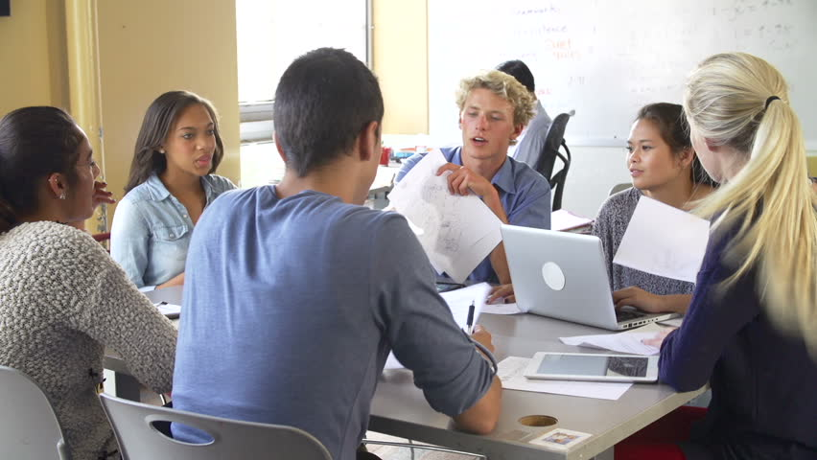

In this photo I can see a group of people are discussing. I think they stay at the library. On the left we can see a woman is wearing a white shirt. She has got long black hair and brown skin. Next to her is a man who has got short hair, fair skin and he is wearing shirt too. He is carrying a document file. He is talking about something and everyone follow him. They look so focus on this discussing. On the table there are some books and laptops. I guess they are preparing for new project of their work. In my opinion it’s an interesting of team work.

**PRACTICE 10**



In the pictures, I see a lot of people and they are sitting around together. See them it is so much fun. I’m sure this party is great. Look, everyone is raising their glasses. I’m not sure, I see all ages in here, I think they’re a family. The man with the hat in the middle of the table looks the oldest. Let’s see, behind them there are many trees. Wow, this is an outdoor party. The weather must be beautiful. Um…, I really like this picture. Look at the picture, I really want to join them, it’s really fun

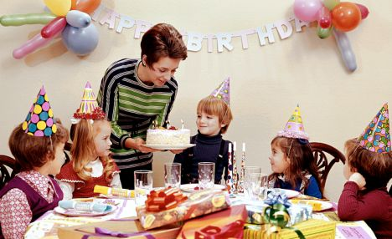

In the picture, I can see the woman and five children attending the birthday party. I think the woman is the mother of the boy in the black shirt and the birthday party is his . The boy looks very happy. The mother is holding a birthday cake for her son. The boys and girls are wearing five colorful birthday hats look very beautiful. They are blowing the candles and are singing song “happy birthday”. They look very happy. On the table there are colorful gifts, candies, glasses. Behind the mother has the words happy birthday and there are many balloons. They have a great time at the birthday party. I like this picture because it's so cute and fun.